Formal Use Cases
TITLE | GATHER
PRIMARY ACTOR | Player
SUCCESS | - Player interacts with resource node/resource object  - Game determines resources that will be gathered  - Player is prompted to place desired resources in inventory
ALTERNATIVE | 1a.1. Resource is not interactable  2b.1. Resource has no resource to give player  2b.2. Resource node/object disappears
PRE-CONDITION | Player is within range of resource
POST-CONDITION | Player collections receives resources and the resource node/object disappears
ASSUMPTIONS | Player has space in inventory
STORY | The player walks up to and interacts with a resource node or a droid that is scrapable, the game checks the appropriate range of resources to be gained from that object, and then determines the appropriate amount of resources to give the player, either random or deterministically. After, the player receives the resources in their inventory, and a UI element indicates successful gathering.

TITLE | Interact
PRIMARY ACTOR | Player
SUCCESS | - Player interacts with NPC  - Dialogue system gets text from NPC  - Dialogue system displays text
ALTERNATIVE | 1a.1. NPC is not interactable  2a.1. NPC has no dialogue to show  2a.2. Player is informed that that NPC doesn’t want to talk right now
PRE-CONDITION | Player is within range of NPC
POST-CONDITION | Dialogue system displays choices for player, player makes dialogue choices
ASSUMPTIONS | NPC is friendly
STORY | The player walks up to a non-enemy NPC and interacts with them. The game brings the player into a dialogue screen if they’re interactable and using UI elements prompts the player with dialogue options. Alternatively, the NPC is non-interactable and there is no response.

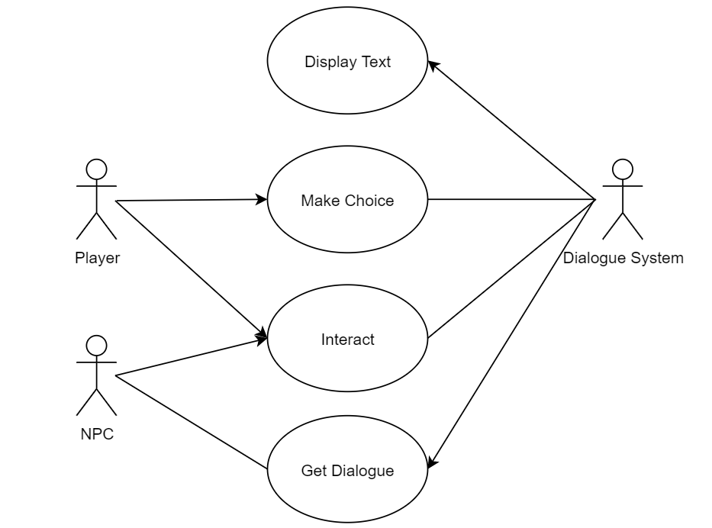
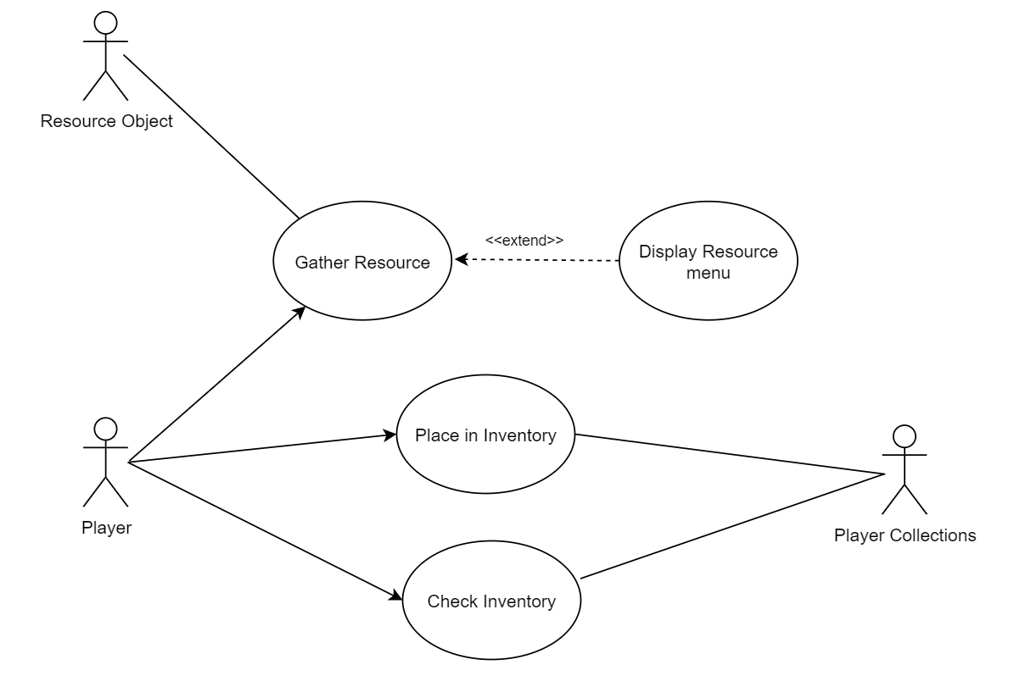
Use Case Diagrams

